I
- Modify the BFS implementation to store and print the shortest path from the source to every vertex.
CODE:
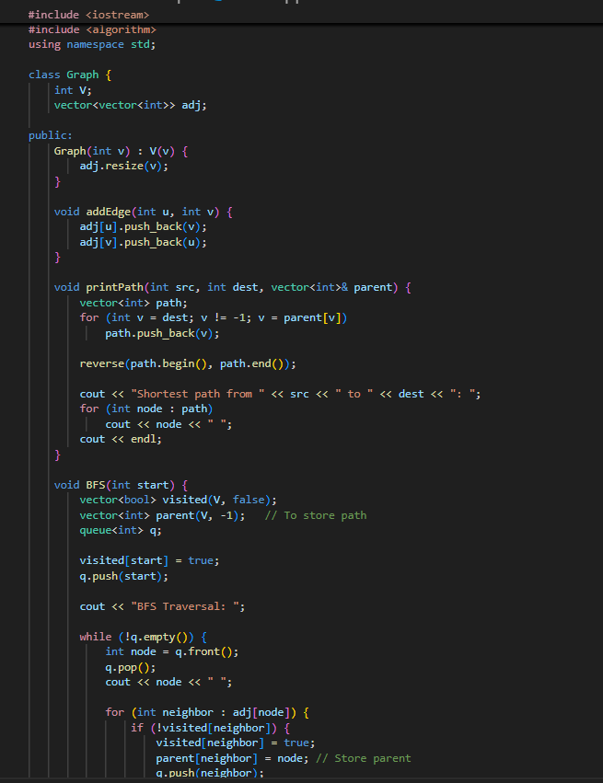
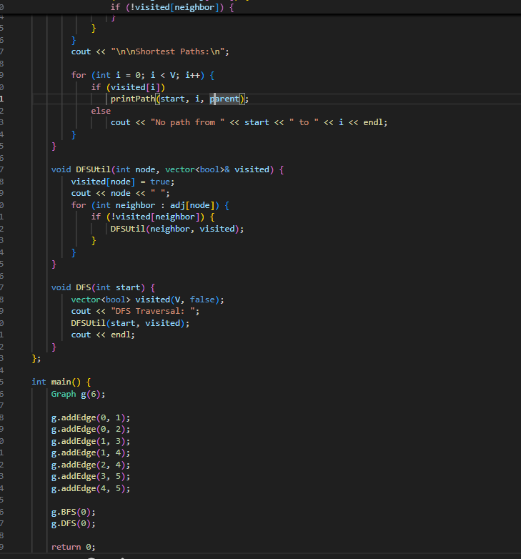

Output:
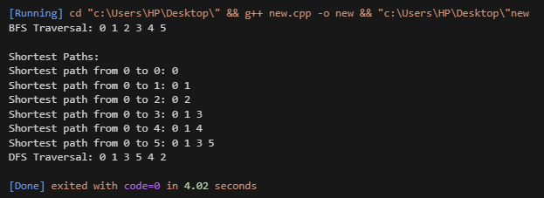

2. Extend DFS to detect cycles in an undirected graph.
CODE:
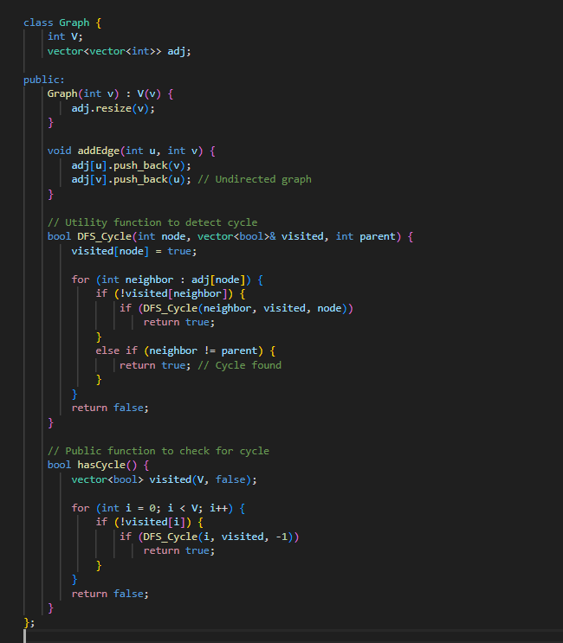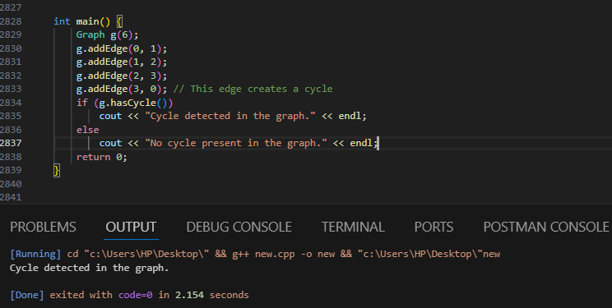
Output:

- Modify the program for directed graphs.

CODE:
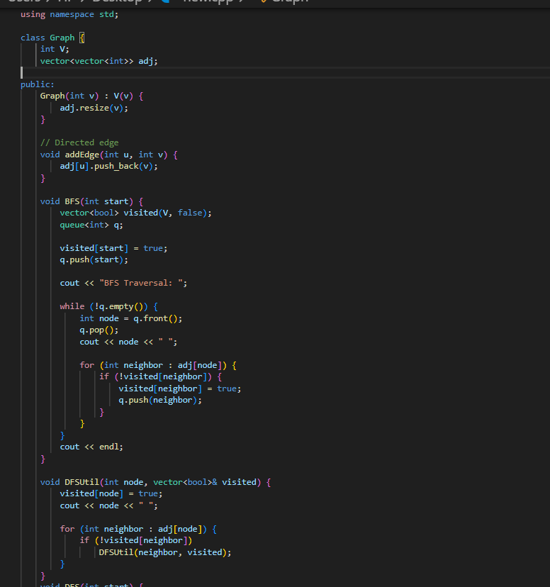
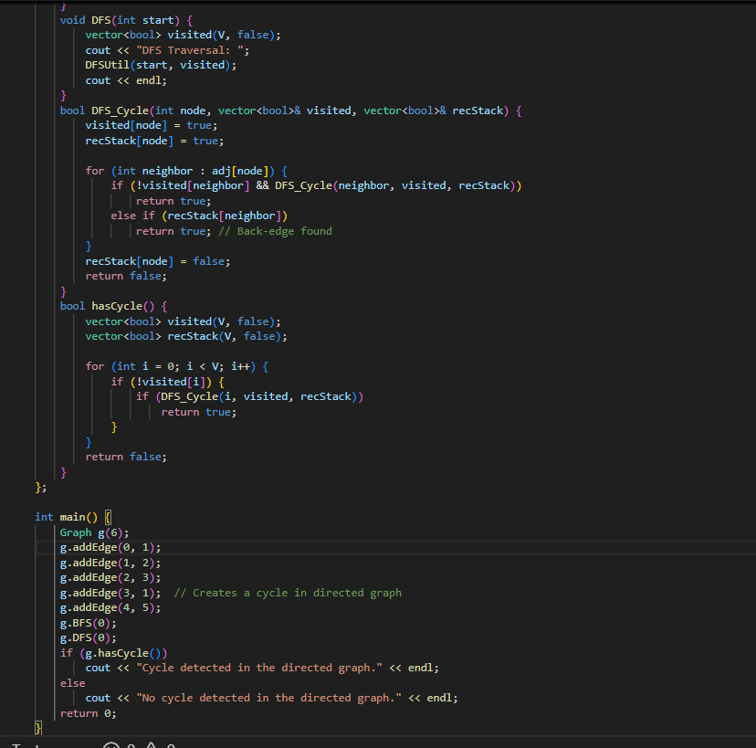

Output:
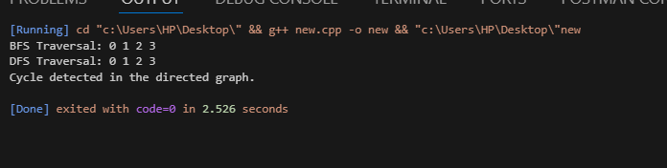

- Apply BFS on a weighted graph by ignoring weights.

CODE:
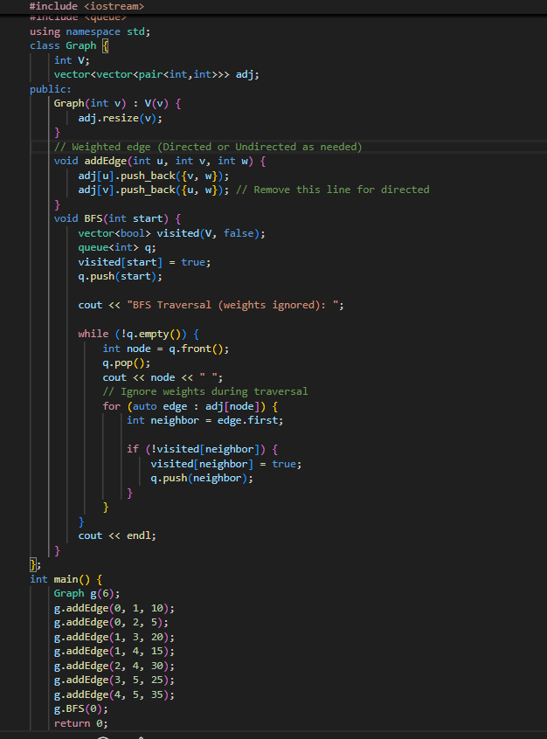

Output:
